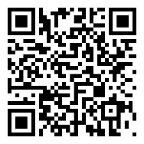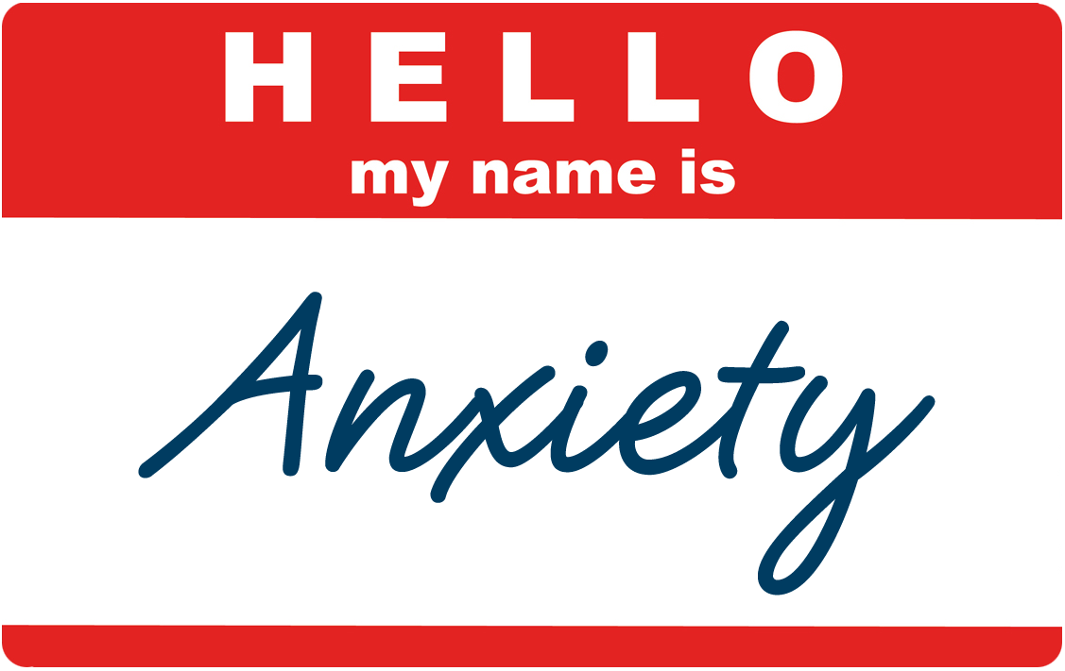

**Anxiety Management Workshop**

Fall, 2015

**TCNJ Counseling and Psychological Services**

**Room 107**

***In four short weeks, learn to manage your anxiety so that IT isn’t managing YOU!***

***1. Fridays: September 18—October 9 11-12pm Education Building Rm. 205***

***Or***

***2. Tuesdays: October 20—November 10 3:30-4:30 Social Science Rm. 130***

***If you are looking for a group experience, check out our Chill Out Group***

***Beginning mid February***

**Sign-up:**

**Scan the code *or* email leahym@tcnj.edu**

***Choose Session 1 or 2***