LEARNING from FAILURE
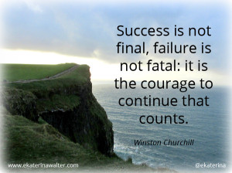
Failure is inevitable on the path to success. We are conditioned to achieve and succeed but often struggle when we fall short – with negative consequences to our self-esteem and motivation. Don’t buy into the narrative that failure is to be avoided and that it is devastating when it occurs.

Here are some examples of a new perspective on failure:
Strategies for Learning from Failure
When we Learn from Failure (and when we don’t)
The 4 Keys to Learning from Failure
8 TED Talks about Learning from Failure
21 Ways to Learn from Failures
30 Powerful Quotes on Failure
The Success-Failure Project at Harvard

